


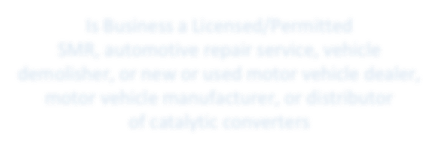





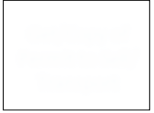



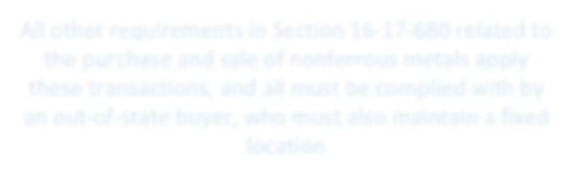

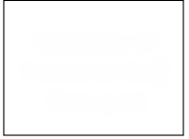

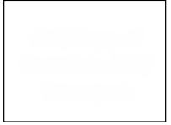



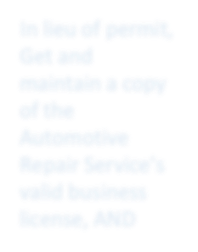




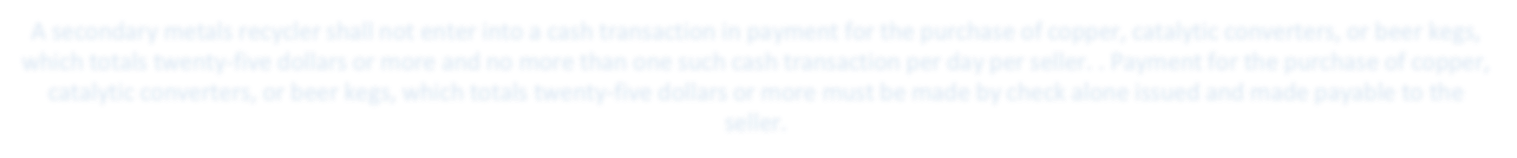





SC Catalytic Converter Purchasing Requirements
for Secondary Metals Recyclers
Business**
Individual*
Is Seller a Business
or Individual?
Get/Copy of
Permit to Sell/ Transport
Is Business a Licensed/Permitted
SMR, automotive repair service, vehicle demolisher, or new or used motor vehicle dealer, motor vehicle manufacturer, or distributor
of catalytic converters
Get/Copy of
Permit to Sell/ Transport
No
Must copy and maintain all of the
following:
Get a copy of a record or
receipt showing:
- Name of the person or
company that removed the
converter;
- the name of the person for whom the work was completed;
- make and model of the vehicle from which the converter was removed;
- the VIN of the vehicle from which the converter was removed;
- part number of other identifying number of the converter; and
- certificate of title or certificate of registration which must show seller’s ownership interest in the vehicle from with the converter was removed
Yes
- Repair order number,
when applicable;
- Date of repair or removal;
- Identity of individual or entity that removed the converter, when applicable; and
- VIN of the vehicle from which converter was removed
Yes
Automotiv
Repair
NoService?
Get/Copy of
Permit to Sell/ Transport
Get and
maintain a copy of the Seller’s valid business license
*Purchase must take
place at the fixed site of the SMR
**Purchase may take place at the fixed location
of the seller ONLY if seller is a licensed automotive repair service, a licensed demolisher, a licensed SMR, or a licensed motor vehicle dealer
Records of transactions must be maintained for a minimum of one
year***, and be open for inspection during normal business hours by law enforcement or local and state government agencies, and must include:
***Records may be in an
electronic database that is accessible to Law Enforcement on request
a photocopy of the seller's identification, a photocopy of the seller's permit to
transport and sell nonferrous metals, if applicable
a photocopy of the seller's identification, a photocopy of the seller's permit to
transport and sell nonferrous metals, if applicable
the license plate number of the seller's motor vehicle, if available
the seller's photograph. If the secondary metals recycler has the seller's photograph
on file, the secondary metals recycler may reference the photograph on file without making a photograph for each transaction; however, the secondary metals recycler shall update the seller's photograph on an annual basis
the weight and size or other description of the nonferrous metals
purchased
a signed statement from the seller stating that the seller is the rightful owner or is entitled to
sell the nonferrous metals being sold
A secondary metals recycler shall prominently display a twenty-inch by thirty-inch sign in the secondary metals recycler's fixed site that states: "NO NONFERROUS METALS, INCLUDING COPPER, MAY BE PURCHASED BY A SECONDARY METALS RECYCLER FROM A SELLER UNLESS THE SELLER IS A HOLDER OF A RETAIL LICENSE, AN AUTHORIZED WHOLESALER, A CONTRACTOR LICENSED PURSUANT TO ARTICLE 1, CHAPTER 11, TITLE 40, CODE OF LAWS OF SOUTH CAROLINA, 1976, A GAS, ELECTRIC, COMMUNICATIONS, WATER, PLUMBING, ELECTRICAL, OR CLIMATE CONDITIONING SERVICE PROVIDER, OR THE SELLER PRESENTS THE SELLER'S VALID PERMIT TO TRANSPORT AND SELL NONFERROUS METALS ISSUED PURSUANT TO SECTION 16-17-680, CODE OF LAWS OF SOUTH CAROLINA, 1976.
A secondary metals recycler shall not enter into a cash transaction in payment for the purchase of copper, catalytic converters, or beer kegs, which totals twenty-five dollars or more and no more than one such cash transaction per day per seller. . Payment for the purchase of copper, catalytic converters, or beer kegs, which totals twenty-five dollars or more must be made by check alone issued and made payable to the seller.
the amount paid
the date of purchase, the name and address of the seller
SMR Must have permit issued by Sheriff
All other requirements in Section 16-17-680 related to the purchase and sale of nonferrous metals apply these transactions, and all must be complied with by an out-of-state buyer, who must also maintain a fixed location

In lieu of permit, Get and maintain a copy of the Automotive Repair Service’s valid business license, AND

